MTH27101: Methods of Applied Mathematics

Homework 1

20121229 JunPyo Park

1. data.json
   1. I entered the data for each student like below.

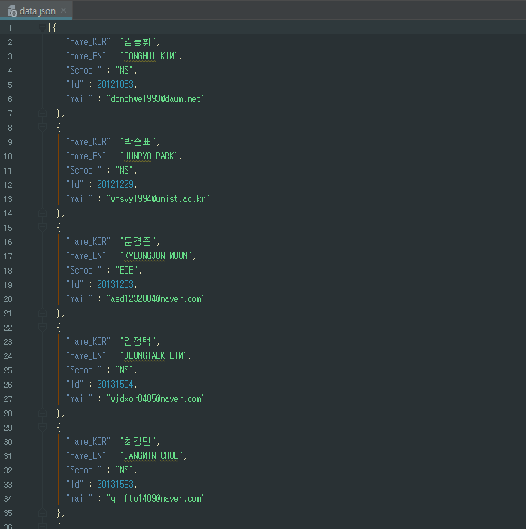

1. DB_Processing.ipynb
   1. Load database

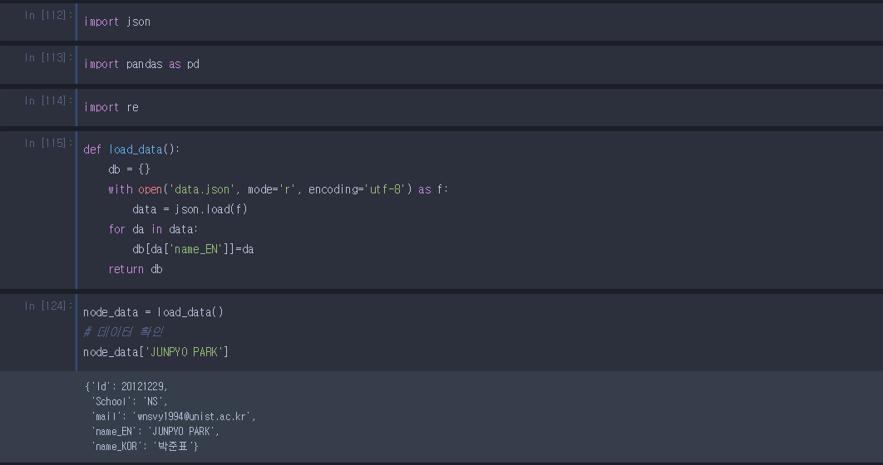

* 1. Making node_list : I select student’s English name as a node

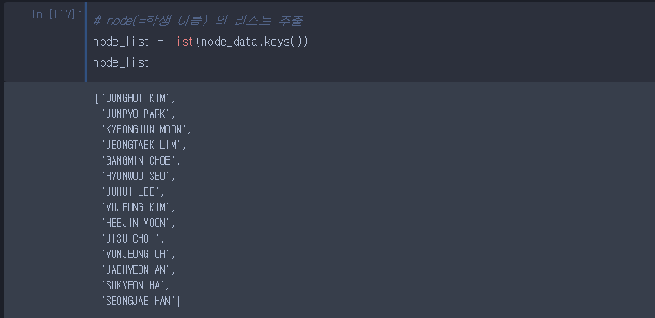

* 1. Add some attributes to each node.



* + 1. ‘first_name’ : English first name
    2. ‘mail_web’ : 사용하는 메일 사이트(naver, daum, unist…)
    3. ‘start_year’ : 입학년도(12,13,14…)
  1. Calculate adjacency matrix and save them as a CSV files.

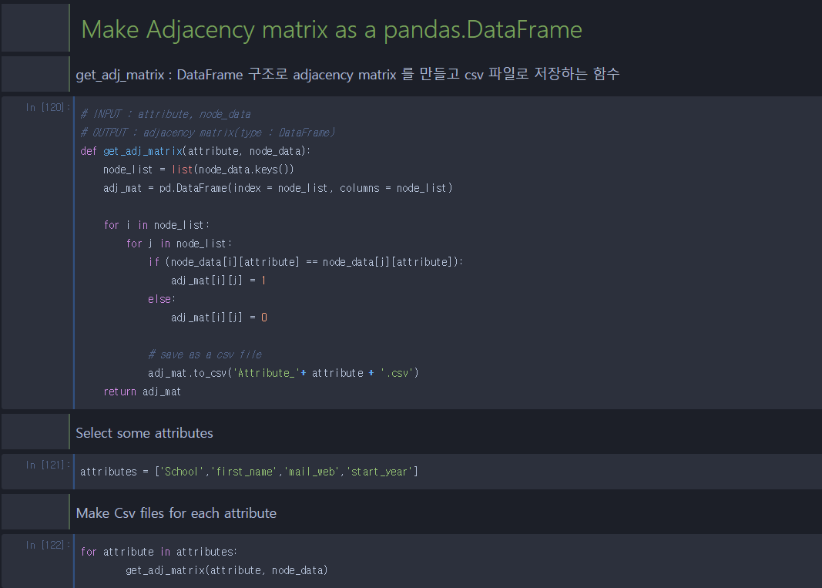

I select 4 features : ‘School’, ‘first_name’, ‘mail_web’, ‘start_year’

* 1. After running this code, we can find csv files for each attribute.

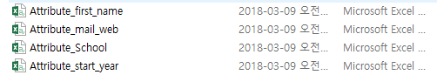

1. Using Gephi tools to make graph.

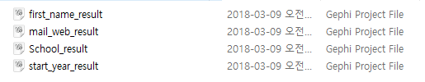

1. These are the results.
   1. Attribute : ‘first_name’

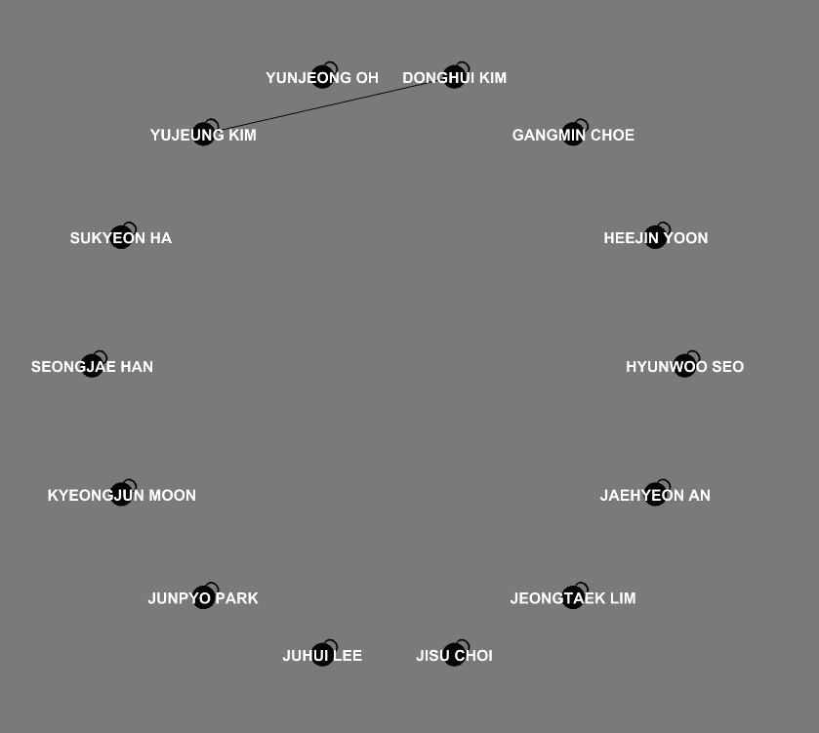

* 1. Attribute : ‘mail_web’

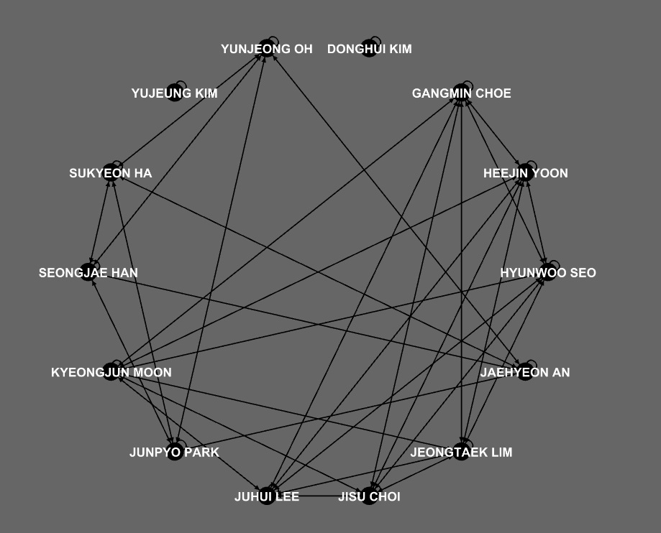

* 1. Attribute : ‘School’

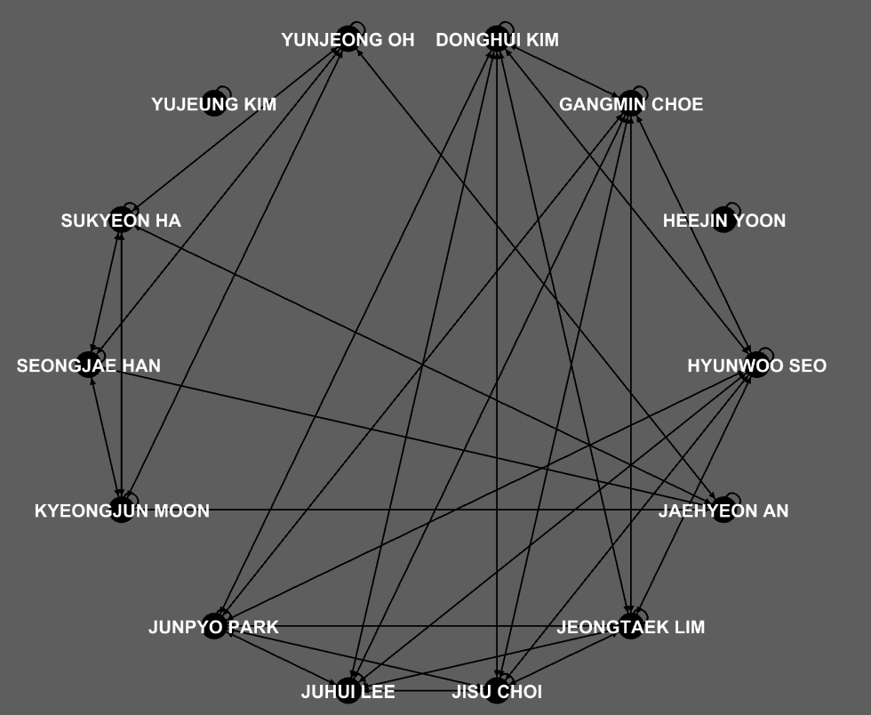

* 1. Attribute : ‘start_year’

